open gitbash because to run git clone command from htdocs

step 2:

git clone "zipfile link from github"

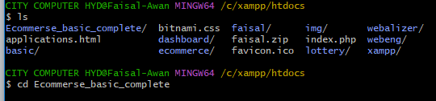



Now write exact this



Now setup the database. Open project from htdocs in vscode and goto env file give name to db and create the db

Next command composer install

download zip file or clone the project

cd laravel-starter

cp .env.example .env

open .env and update DB_DATABASE (database details)

run : composer install

run : php artisan key:generate

run : php artisan migrate:fresh --seed

run : php artisan serve

